St Gregory’s Catholic Primary School
‘Loving and Learning’
The St Gregory’s Curriculum
Humanities - Geography
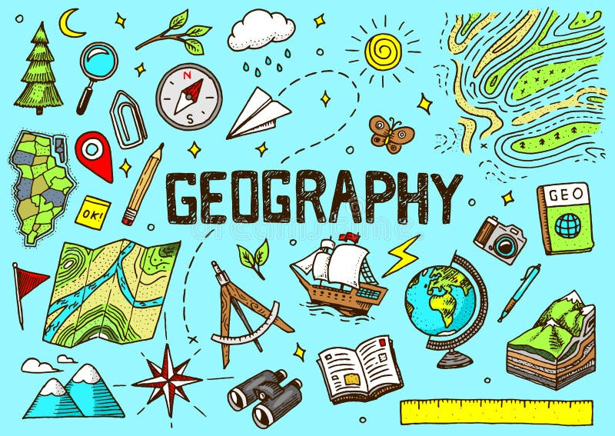

Genesis 1:31 God saw all he had made, and indeed it was very good.

Catholic Social Teaching
Stewardship. The Common Good. Promoting Peace.

Catholic School Pupil Profile
Curious. Grateful.

Curriculum Intent for Geography
It is our intention that pupils at St Gregory's will develop a lifelong fascination about the world and its people. They will acquire new skills that are identified within the National Curriculum for Geography: locational knowledge, place knowledge, human and physical geography and geographical skills and fieldwork.

Where possible, our Geography topics provide pupils with opportunities to learn about their local area.
For example:
- 'All About Me and My School' in Year 1
- 'Investigating Our Local Area' in Year 3
- 'Warley Woods' in Year 6

Topics such as these provide our pupils with a Geography curriculum that is relevant and authentic, enabling them to draw upon their everyday experiences and own interests to make sense of geographical processes.

It is our intention as a school to provide our pupils with, not only core geographical knowledge, but an appreciation and empathy for both their local and global environment. We actively encourage the children to identify and celebrate the differences between the world's people, places and communities. As children progress through the school, their growing knowledge should deepen their understanding of the interaction between physical and human processes, and the formation and use of landscapes and environments.

Reading and Writing Curriculum:
In a similar way, our Reading and Writing Curriculum has been designed with cross-curricular links in mind – with the aim of providing meaningful reading and writing opportunities for our pupils that are linked to the thematic curriculum.

For example:
- Reception study ‘The Gruffalo’ by Julia Donaldson during their ‘If You Go Down to the Woods Today…’ topic.
- Year 1 study ‘The Lighthouse Keeper’s Lunch’ by David and Ronda Armitage during their ‘Oh, I Do Like to be Beside the Seaside’ topic.
- Year 4 study ‘Christophe’s Story’ during their ‘Seven Worlds, One Planet’ topic.
- Year 5 study ‘The Explorer’ by Katherine Rundell during their ‘Save the Rainforest’ topic.

Theme Days:
Where possible, teachers incorporate ‘Theme Days’ into their Humanities topics to provide meaningful and memorable enrichment opportunities and spark the children’s love of learning. This can be done at the beginning of a new Humanities topic to captivate the children’s interest in the learning from the very start. Alternatively, it may occur at the end of a topic as a celebration of their learning. These theme days involve many exciting activities, such as:
- Dressing up/role-play/drama activities
- Special visitors
- External trips
- Practical activities
- Fundraising events
- Performing or speaking in assemblies

Curriculum Implementation for Geography

Effective teaching:
Teaching at our school is underpinned by strong subject knowledge. Our teachers use a wide range of age-appropriate strategies to create Humanities lessons that are effective, enjoyable and memorable.

Appropriate discussion:
Pupils are provided with ample opportunity to discuss geographical matters, such as natural disasters, climate change, recycling, etc. It is valuable for our learners to not just be given the information and simply retain it, but for them to share their opinions, voice their queries and show empathy where appropriate.

Relevant learning:
Our most successful learning in Humanities occurs when we as teachers incorporate the children's owns interests, talents and experiences into the lesson. Pupils are more motivated to complete activities where there is an element of real-life application, where they feel like the work they are producing will be utilised or make a difference to people's lives in some way.

Fieldwork:
Fieldwork is at the heart of our school's Geography curriculum. We believe it is crucial for children to be given the opportunity to explore and appreciate their local area. This is evident in the Geography topics which incorporate local area study and/or going outside to further their geographical understanding. Fieldwork is not simply about the pupils being outside - it is an opportunity for them to develop their sense of place. We support our pupils to describe their experiences outside: what can you see/hear/feel? What do you like/dislike? What could be done to improve this area? Is this environment looked after?

Curriculum Impact for Geography

Core knowledge:
The Geography curriculum in our school is highly effective in equipping our pupils with core geographical knowledge. The children in our school thoroughly enjoy exploring the world and all of its diversity – drawing comparisons between different places, people and cultures. Learning the facts and figures associated with different parts of the world enable our pupils to build connections and have a sense of the globe.

Enquiry:
It is our aim as teaching staff to provoke our pupils’ fascination and curiosity about their Geography topics through the enthusiasm that we as teachers demonstrate whilst teaching the subject. We want to make our pupils feel like they are going on an adventure, picking up clues about the topic along the way. As a result, pupils show great excitement when learning about different areas of the world.

Mapping:
Maps are an integral part of our Geography curriculum. We have many mapping resources in school, which the children use from a very early age to improve their locational knowledge of the world and fieldwork skills. As a result, children develop a sense of place and the globe.

Graphicacy:
Data handling is a skill that is regularly incorporated into the children’s Geography lessons at our school. Over time, our children develop the skills to record, present and explain this data with increasing independence.

Vocabulary:
Our pupils are exposed to geographical vocabulary from a very early age. As well as exposure within the lessons on an audial level (through repeated application with the class teacher), the children are also provided with visual reminders of this vocabulary. Geographical vocabulary is always displayed on the children’s topic display board and referred to regularly during the lessons. As a result, the children use this vocabulary with accuracy and confidence in their learning.

Digital technologies:
A variety of digital technologies are used within Geography lessons to provide more engaging learning experiences for our pupils. Every classroom has an interactive SMART board, enabling quick and easy manipulation of images (such as maps) to support our pupils’ understanding. In conjunction with the maps in our atlases, children are also exposed to digital mapping (e.g. Google Earth, Google Maps, Street View, etc.) to provide a more interactive and adjustable mapping experience for our pupils. Our pupils thoroughly enjoy using laptops to conduct research into their Geography topics.

Formative Assessment:
Our school’s marking policy is underpinned by the school’s mission statement: ‘Loving and Learning’. The policy establishes consistency in marking and feedback across the whole school to ensure pupils are provided with regular, high-quality written or verbal feedback that leads to a consistently high level of pupil achievement and attitude to their learning and written work. We believe that learning should be a rewarding and enjoyable experience and that marking and feedback should equip children with the knowledge and understanding necessary for them to become independent learners and improve their work.

Summative Assessment:
At the start of all Humanities topics, children stick a ‘Unit Marker’ into their book. They start the topic by recording facts they already know. At the end of the sequence of learning (approximately 6 lessons), children will then go back to their ‘Unit Marker’ and record all the facts they know now. These unit markers are used as a summative assessment strategy to show the progress in children’s attainment from the beginning to the end of a Humanities topic.

